Ideation Phase
Empathize & Discover

Date | 20-July-2026
Team ID
Project Name | AI Admission & Admin AI Admission System
Maximum Marks | 4 Marks

Empathy Map Canvas:
An empathy map is a simple, easy-to-digest visual that captures knowledge about a user’s behaviours and attitudes.

It is a useful tool to helps teams better understand their users.
Creating an effective solution requires understanding the true problem and the person who is experiencing it. The exercise of creating the map helps participants consider things from the user’s perspective along with his or her goals and challenges.
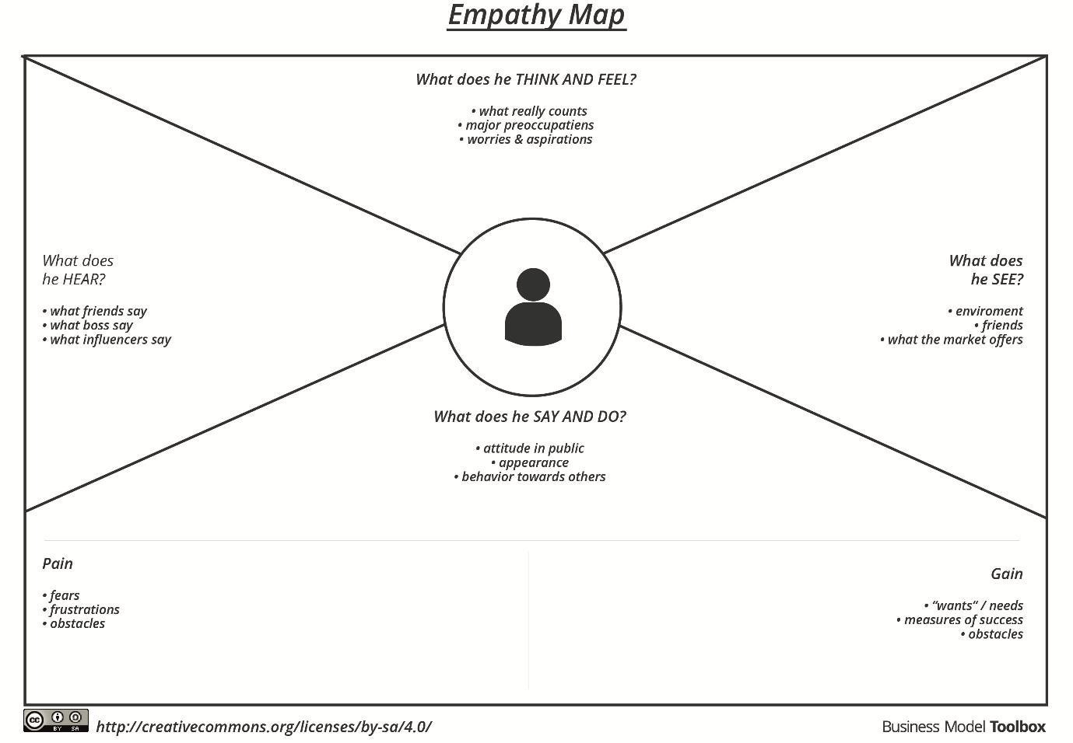
Example:

Empathy Map Canvas Data Sheets:
Section 1: What does he think and feel Will we clear the manual enrolment verification backlog before strict registration deadlines pass? I feel anxious about missing critical compliance errors during manual document reviews. I want a streamlined dashboard to quickly flag high-risk applicants and route high-discount approvals to executives.
Section 2: What does he hear From University Management: We need to optimize our conversion rate and hit our freshman enrolment targets this quarter. From Prospective Students: Why is my intake status still marked as pending? I need to finalize my class schedule!
Section 3: What does he see A cluttered desktop screen jammed with open browser tabs, unorganized Excel spreadsheets, and long email queues. Competitor universities using fast, automated AI chat response systems to instantly capture student interest.
Section 4: What does he say and do What he says: We are working as fast as possible, but the sheer volume of student documents this semester is unprecedented. What he does: Manually copies data across legacy systems, double-checks eligibility criteria boundary rules, and routes exceptions via email.
Section 5: Pain Wasting hours sorting through duplicate profile records or manually checking standard registration fee discount limits. Extreme workplace stress and burnout during the peak two weeks admissions registration window.
Section 6: Gain An automated Salesforce layout that immediately flags student application risk indexes dynamically. An autonomous Agent force companion successfully handling repetitive support questions.

